1. A F&B manager wants to determine whether there is any significant difference in the diameter of the cutlet between two units. A randomly selected sample of cutlets was collected from both units and measured? Analyze the data and draw inferences at 5% significance level. Please state the assumptions and tests that you carried out to check validity of the assumptions.

Soln:- α = 0.05

Inputs(X) = Diameter of Unit A and Unit B which are discrete.

Output(Y) = difference in diameter which is continuous.

SO, we apply 2 sample t-test

1. Normality test

Hypothesis for Unit A

H0 = Data is normally distributed

Ha = Data is not normally distributed

We get P = 0.32 which is greater than 0.05 then null hypothesis is accepted. So, data is normally distributed.

Hypothesis for Unit B

H0 = Data is normally distributed

Ha = Data is not normally distributed

We get P = 0.52 which is greater than 0.05 then null hypothesis is accepted. So, this data is also normally distributed.

As both the data follows normal distribution and external conditions are not equal so we will proceed for variance test.

Hypothesis for variances of Unit A and B

H0 = Variance of Unit A = Variance of Unit B

Ha = Variance of Unit A is not equal to Unit B

P = 0.3136 > 0.05, we fail to reject null hypothesis. So variances are equal.

2 sample t-test

H0 = Average of diameter of Unit A is equal to Average of diameter of Unit B

Ha = Average of diameter of Unit A is not equal to Average of diameter of Unit B

P = 0.432 > 0.05, we fail to reject null hypothesis.

Inference is that there is no significant difference in the diameter of Unit A and B.

1. A hospital wants to determine whether there is any difference in the average Turn Around Time (TAT) of reports of the laboratories on their preferred list. They collected a random sample and recorded TAT for reports of 4 laboratories. TAT is defined as sample collected to report dispatch. Analyze the data and determine whether there is any difference in average TAT among the different laboratories at 5% significance level.

Soln:- Inputs are 4 lab reports. So Input is Discrete in more than 2 categories.

Output is continuous as we are trying to see the difference in average TAT.

we proceed with ANOVA one-way test

1) Normality test- We will see if data is normally distributed or not

Create hypothesis for Lab 1

Ho= Data is normally distributed

Ha=Data is not normally distributed

P-value is >0.05. P High Ho Fly.So data is normally distributed

Create hypothesis for Lab 2

Ho= Data is normally distributed

Ha=Data is not normally distributed

P-value is >0.05. P High Ho Fly.

So data is Normally distributed

Create hypothesis for Lab 3

Ho= Data is normally distributed

Ha=Data is not normally distributed

P-value is >0.05. P High Ho Fly.

So data is normally distributed

Create hypothesis for Lab 4

Ho= Data is normally distributed

Ha=Data is not normally distributed

-value is >0.05. P High Ho Fly.

So data is normally distributed

2) Variance Test

Create Hypothesis for variances of Lab 1 and Lab 2

Ho= Variance of TAT of Lab 1 is equal to variance of TAT of Lab 2

Ha= Variance of TAT of Lab 1 is not equal to variance of TAT of Lab 2

P-value>0.05. P High Ho fly. We fail to reject Null hypothesis.

So we will accept it and hence Variances of 1 is equal to variances of 2

Create Hypothesis for variances of Lab 2 and Lab 3

Ho= Variance of TAT of Lab 2 is equal to variance of TAT of Lab 3

Ha= Variance of TAT of Lab 2 is not equal to variance of TAT of Lab 3

P-value >0.05. P High Ho fly. We fail to reject Null hypothesis.

So we will accept it and hence Variances of lab 2 is equal to variances of lab 3.

Create Hypothesis for variances of Lab 3 and Lab 4

Ho= Variance of TAT of Lab 3 is equal to variance of TAT of Lab 4

Ha= Variance of TAT of Lab 3 is not equal to variance of TAT of Lab 4

P-value>0.05. P High Ho fly. We fail to reject Null hypothesis.

So we will accept it and hence Variances of lab 3 is equal to variances of lab 4.

Create Hypothesis for variances of Lab 4 and Lab 1

Ho= Variance of TAT of Lab 4 is equal to variance of TAT of Lab 1

Ha= Variance of TAT of Lab 4 is not equal to variance of TAT of Lab 1

3) As there are more than 2 discrete variables and output variable TAT is a continuous variable. Hence we will go with Anova one way test.

Ho= Average TAT for all the samples is same

Ha= Averages TAT for all the samples is not same

SImilarly by doing for different lab combinations you can see that P -value is > 0.05. P High and Ho Fly.

Hence there is no significant difference in the average TAT for all the labs.

3. Inputs are 4 discrete variables (east,west,north,south).

Output is also discrete. We are trying to find out if proportions of male and female are similar or not across the regions

We proceed with chi-square test

Create hypothesis

Ho= Proportions of Male and Female are same

Ha= Proportions of Male and Female are not same

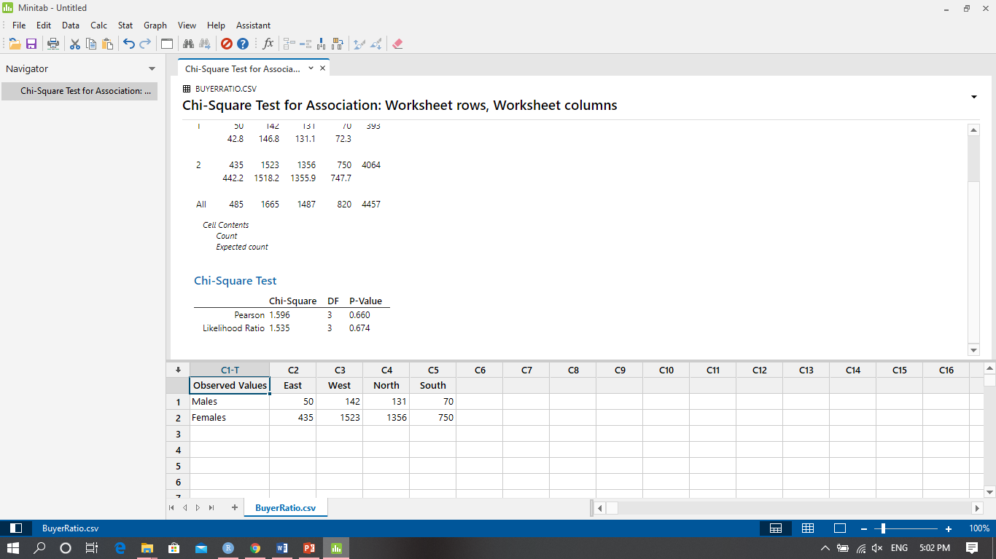

P-value>0.05.Hence we fail to reject Null.

Hence proportion of male and female across regions is same.

1. Inputs are 4 discrete variables and output is whether the proportions are same or not.

We proceed with chi square test.

Ho= Proportions of customer are same

Ha= Proportions of customers are not same

Using r code , P= 0.27 > 0.05, so fail to reject null hypothesis

So all the countries have same defective%.

1. Inputs are 2 discrete variables.

Output is Discrete as we are trying to find out if proportions of male and female walking in to the store is same or not

We proceed with 2-proportion test

Create hypothesis

Ho= Proportions of Male and Female are same

Ha= Proportions of Male and Female are not same

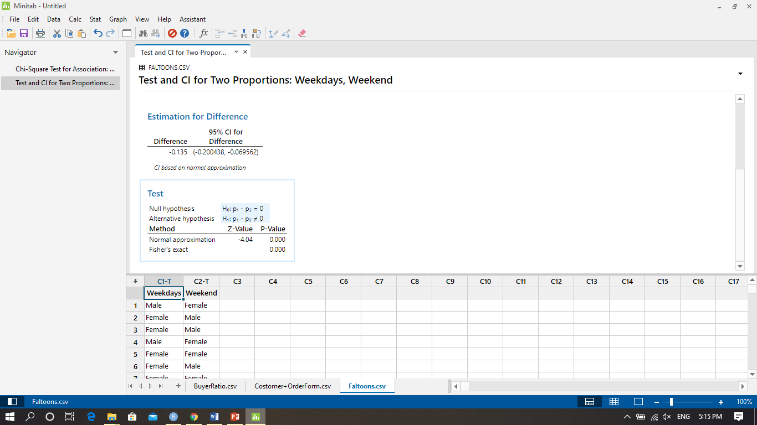

P-value is less than 0.05 and hence we fail to reject Null.Hence proportions of Male and Female are not same

Now we will try to find out whose proportion is higher. We create another hypothesis

Ho= Proportions of Male is less than or equal to Female

Ha= Proportions of Male is greater than Female

P-value <0.05 and hence we reject null. Hence proportion of Male is greater than Female.